Suppose you have a dataset with many variables, and you want to check:

* if there are any duplicated for each of the observation
* replace duplicates with random value from pool of existing values.

In this manner, let’s create a sample dataset:

df <- structure(list(

v1 = c(10,20,30,40,50,60,70,80)

,v2 = c(5,7,6,8,6,8,9,4)

,v3 = c(2,4,6,6,7,8,8,4)

,v4 = c(8,7,3,1,8,7,8,4)

,v5 = c(2,4,6,7,8,9,9,3))

,.Names = c("ID","a", "b","d", "e")

,.typeOf = c("numeric", "numeric", "numeric","numeric","numeric")

,row.names = c(NA, -8L)

,class = "data.frame"

,comment = "Sample dataframe for duplication example")

which has the following interesting characteristics:

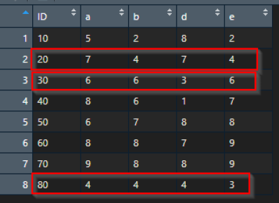

Upon closer inspection, one will see that there are many duplicated values across different variables (variable ID, variable a, variable b, variable d and variable e). So let’s focus on:

* row 2 has two times duplicated values (2x value 4 and 2x value 7)
* row 3 has three times duplicated values (3x value 6)

Our pool of possible replacement values are:

possible_new_values <- c(1,2,3,4,5,6,7,8,9

Creating loop for slicing the data, loop through the duplicated positions, at the end looks like:

for (row in 1:nrow(df)) {

vec = df %>% slice(row) %>% unlist() %>% unname()

#check for duplicates

if(length(unique(vec)) != length(df)) {

positions <- which(duplicated(vec) %in% c("TRUE"))

#iterate through positions

for(i in 1:length(positions)) {

possible_new_values <- c(1,2,3,4,5,6,7,8,9)

df[row,positions[i]] <- sample(possible_new_values

[ ! possible_new_values %in% unique(vec)],1)

}

}

}

revealing the final replacement of values in

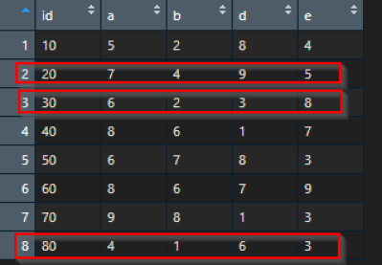

So the end result, when putting old data.frame and the new data.frame (with replaced values) side by side, it looks like:

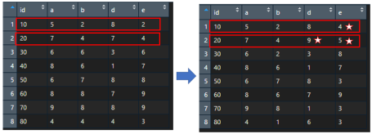

Showing how replacement works per each row across given columns | rows.

Niffy, yet useful data de-duplication or data replacements, when you need one.